Phase – 1 REPORT

Energy Consumption Prediction

Problem Id: 23
Design and develop an end-to-end machine learning regression system to analyze and
predict energy usage using institutional energy data. The project involves selecting a
suitable numerical dataset containing features such as time of day, number of students
present, ambient temperature, and appliance usage. Data preprocessing steps including data cleaning, normalization, and feature transformation are applied to ensure data
quality and consistency. Exploratory Data Analysis is performed to study consumption
patterns, detect outliers, and analyze correlations between features using statistical
summaries and visualizations such as line plots, histograms, and correlation heatmaps.
Based on insights obtained from EDA, relevant features are selected to improve model
performance (PCA, Forward Selection, Backward Selection). A machine learning
regression model is then developed and evaluated to predict energy usage,
demonstrating a complete machine learning workflow from raw data to evaluated
predictive models.

Student Name – Aayushe Saini
University Roll number - 2028609
Section – G Roll number- 27

Student Name – Aanya Singh
University Roll number - 2028602
Section - G Roll number- 24

- Problem Description:
This project focuses on designing a machine learning-based regression system to predict energy consumption in a college building. Energy usage in institutions depends on multiple factors such as time of day, number of students present, environmental conditions, and appliance usage. Efficient prediction of energy consumption can help in optimizing electricity usage, reducing wastage, and promoting sustainable energy practices.
In this project, a dataset representing institutional energy usage is analyzed. The system uses features like temperature, number of students, appliance usage, and time to understand patterns in energy consumption. Machine learning techniques are applied to build a predictive model that estimates energy usage accurately.
This problem has real-life significance in smart campuses, energy management systems, and sustainable infrastructure development. By predicting energy consumption, institutions can plan resource usage efficiently and reduce operational costs.

- Steps of Implementation:

- Data Collection
A dataset representing energy consumption in a college building is collected or synthetically generated. The dataset includes features such as time of day, number of students, temperature, appliance usage, and other relevant parameters.
- Data Preprocessing
The collected data is cleaned by handling missing or inconsistent values. Irrelevant features (such as random noise or identifiers) are identified. Data normalization and scaling techniques are applied to bring all features to a common scale, improving model performance.
- Exploratory Data Analysis (EDA)
Various statistical and visualization techniques are used to understand the dataset. Line plots are used to observe trends over time, histograms to analyze distributions, and correlation heatmaps to identify relationships between features. Outliers are also detected and analyzed.
- Feature Engineering and selection
New meaningful features such as weekend indicators may be created. Feature selection techniques like correlation analysis and Principal Component Analysis (PCA) are applied to remove redundant and irrelevant features, improving model efficiency and accuracy.
- Data Splitting
The dataset is divided into training and testing sets (e.g., 80% training, 20% testing) to evaluate model performance on unseen data.
- Model Development
A Linear Regression model is developed using the training data to establish a relationship between the input features and the target variable, enabling accurate prediction of energy consumption.
We have also used random forest regressor and KNN for model development.
- Model Evaluation
The trained model is evaluated using performance metrics such as Mean Absolute Error (MAE), Mean Squared Error (MSE), and R² Score. These metrics help in assessing the accuracy and reliability of the model.
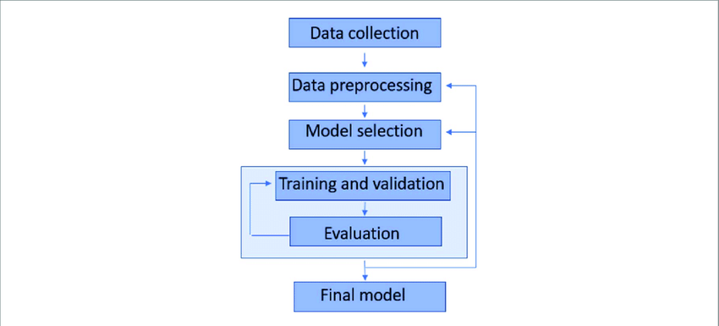
- Prediction and Analysis
The final model is used to predict energy consumption based on input features. The predicted values are compared with actual values to analyze performance.

- Expected Modules/ Libraries to be used:
- Pandas – Used for data manipulation and analysis
- NumPy – Used for numerical computations
- Matplotlib – Used for plotting graphs and visualizations
- Seaborn – Used for advanced data visualization (heatmaps, etc.)
- Scikit-learn – Used for machine learning models, preprocessing, and evaluation

- Expected Evaluation metrics and Plots to be used:

Evaluation Metrics:
- Mean Absolute Error (MAE) – Measures average prediction error
- Mean Squared Error (MSE) – Penalizes larger errors
- R² Score – Measures how well the model fits the data
Plots:
- Line Plot – To visualize energy usage trends over time
- Histogram – To understand data distribution
- Correlation Heatmap – To identify relationships between features
- Scatter Plot – To observe feature vs target relationship
- Box Plot – To find extreme values and outliers

- Required topics from the subject:
- Strings
Used for handling column names, dataset labels, and data formatting.
- Files
Used for reading and writing datasets (CSV files) using Python.
- Functions
Used to modularize code for preprocessing, training, and evaluation.
- Libraries
Used to implement machine learning algorithms and visualization.
- Platform Required:
• Jupyter Notebook
• Python (VS Code / IDLE)

- Books and Link Sources:
• Scikit-learn Documentation: https://scikit-learn.org
• Pandas Documentation: https://pandas.pydata.org
• Matplotlib Documentation: https://matplotlib.org
• Numpy Documentation: https://numpy.org
• Dataset Generation: ChatGPT

